Project Design Phase-2 Customer Journey Map

|  |  |
| --- | --- |
| Date | 14 OCTOBER 2022 |
| Team ID | **PNT2022TMID27338** |
| Project Name | Project – Natural Disaster Intensity Analysis and Classification Using Artificial Intelligence |
| Maximum Marks | 4 Marks |

Customer Journey Map for “Natural Disaster Intensity Analysis and Classification Using Artificial Intelligence”:

Step-1: Goals and needs

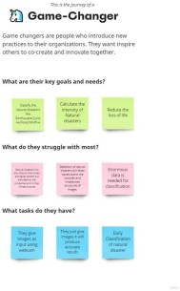

Step 2: Journey Steps

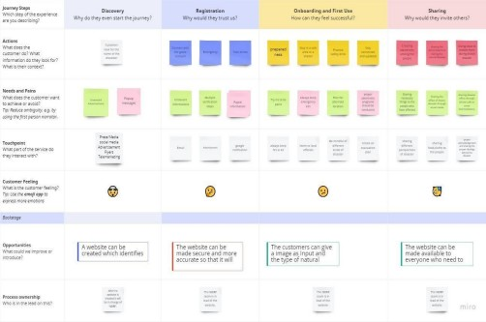

Step 3: Journey Outcomes

